Applied Maths Higher Level 2022

2022 Question 1 (a)
A train takes 40 minutes to travel from rest at station A to rest at station B. The distance between the stations is 20 km. The train left station A at 10:00.
At 10:15 the speed of the train was 32 km h^{–1} and at 10:30 the speed was 48 km h^{–1}.
The speed of 48 km h^{–1} was maintained until the brakes were applied, causing a uniform deceleration which brought the train to rest at B.
During the first and second 15‐minute intervals the accelerations were constant.
- Draw a speed‐time graph of the motion.
- Find the time taken for the first 16 km.
- Find the deceleration of the train.

2022 Question 1 (b)
A ball E is thrown vertically upwards with a speed of 42 m s^{–1}.
𝑇 (< 8) seconds later another ball, F, is thrown vertically upwards from the same point with the same initial speed.
- Find where ball E is after 5 s and the total distance it has travelled in this time.
- Prove that when E and F collide, they will each be travelling with speed ½𝑔𝑇.

2022 Question 3 (a)
A particle is projected out to sea from a point P on a cliff to hit a target 60 m horizontally from P and 60 m vertically below P.
The velocity of projection is 14√3 m s^{–1} at an angle 𝛼 to the horizontal.
Find
- the two possible values of 𝛼
- the times of flight.

2022 Question 4 (a)
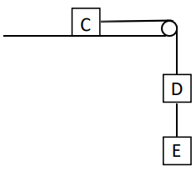
A block C of mass 6m rests on a rough horizontal table.
It is connected by a light inextensible string which passes over a smooth fixed pulley at the edge of the table to a block D of mass 3m. D is connected by another light inextensible string to a block E of mass 2m, as shown in the diagram.
The coefficient of friction between C and the table is $\frac{1}{3}$.

The system is released from rest.
- Show on separate diagrams the forces acting on each block.
- Find the acceleration of C.
- Find the tension in each string.

2022 Question 5 (a)
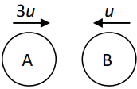
A smooth sphere A of mass 2m, moving with speed 3u on a smooth horizontal table collides directly with a smooth sphere B of mass m, moving in the opposite direction with speed u.
The coefficient of restitution between A and B is e.
Find, in terms of u and e,
- the speed of each sphere after the collision
- the magnitude of the impulse imparted to B due to the collision.
- The loss of the kinetic energy due to the collision is kmu²(1 – e²).
Find the value of k.

2022 Question 5 (b)
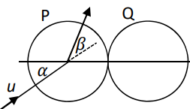
A smooth sphere P has mass m and speed u. It collides obliquely with a smooth sphere Q, of mass m, which is at rest. Before the collision, the direction of P makes an angle 𝛼 with the line of centres, as shown in the diagram.
The coefficient of restitution between the spheres is $\frac{1}{3}$.

During the impact the direction of motion of P is turned through an angle 𝛽.
Show that tan β = $\frac{5\tan{α}}{3+8 \tan^{2}α}$

2022 Question 6 (b)
A particle is attached to one end of a light inextensible string of length 0.5 m. The other end of the string is attached to a fixed point C. The particle moves in a vertical circle.
The greatest and least tensions in the string are 3T and T, respectively.
Find the speed of the particle at the lowest point.

2022 Question 10 (a)
A particle moves in a horizontal line such that its speed 𝑣 at time 𝑡 is given by the differential equation
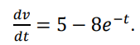

- Given that 𝑣 = 2 when t = 0, find an expression for 𝑣 in terms of 𝑡.
- Find the minimum value of 𝑣.
- Find the distance travelled by the particle before it attains its minimum speed.

2022 Question 10 (b)
The rate of decay at any instant of a radioactive substance is proportional to the amount of the substance remaining at that instant. The initial amount of the radioactive substance is 𝑁 and the amount remaining after time 𝑡 (hours) is 𝑥.
- Prove that 𝑥 = Ne^{-kt}, where 𝑘 is a constant.
- If the initial amount 𝑁 was reduced to $\frac{N}{3}$ in 14 hours, find the value of 𝑘.
- If the amount remaining is reduced from $\frac{N}{3}$ to $\frac{N}{4}$ in 𝑡 hours, find the value of 𝑡.

